1. 
2. **Agenda**:
   1. Kafka consumer related terminologies and where to find more information about it.
3. Let’s first understand the flow of how Kafka Consumer in general is going to read the records from the Kafka Topic.
4.   
   Kafka Consumer can consume records/msgs from multiple topics but not recommended.
5. What are the options available to configure Kafka Consumer.
6. 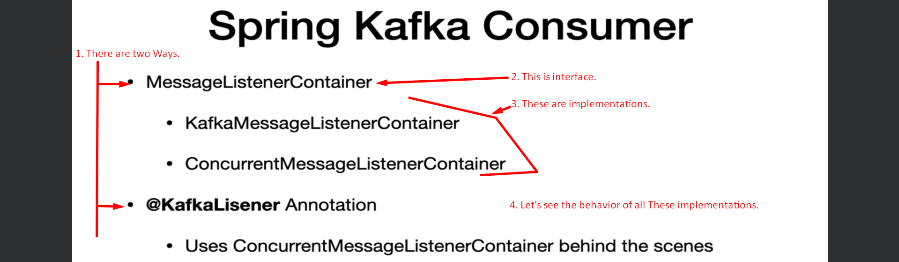
7. Let’s quickly cover what is the behavior of all the implementation shown above.  
   **Let’s start with KafkaMessageListenerContainer**.  
   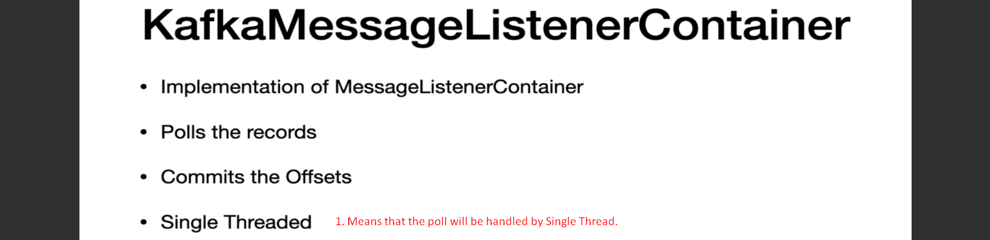
8. **ConcurrentMessageListenerContainer**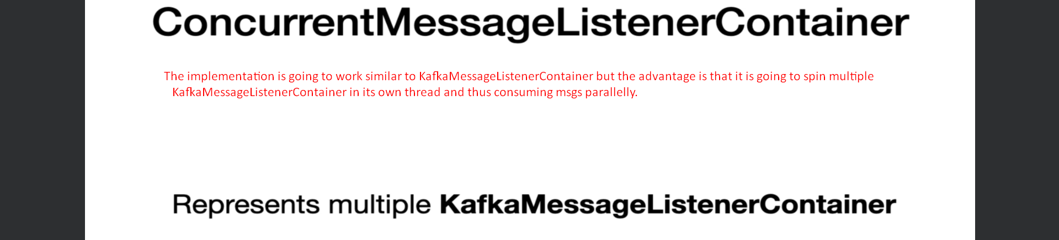
9. The 3rd option is @KafkaListener to configure a consumer.  
     
     
   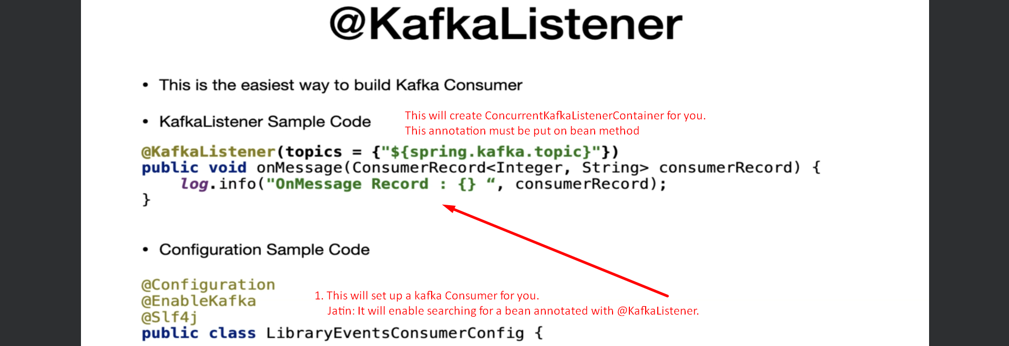
10. **Consumer Configuration**:   
    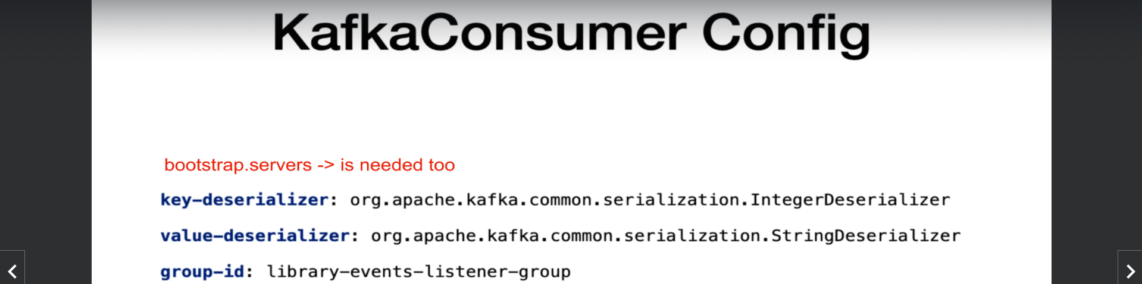
11. **Let us see where we can find more info about Kafka Consumer.  
    All the above discussed info can be found on this page.**